UBC Centre for Applied Ethics Presents:
Dr. Scott S. Graham, University of Texas at Austin
“Hype and Health AI: Ethical Challenges and Interventional Possibilities”
Wednesday, April 19, 2023; 3:30-5:00pm
Location: SPPH Room 491
Zoom Link (Meeting ID: 699 1039 2702)
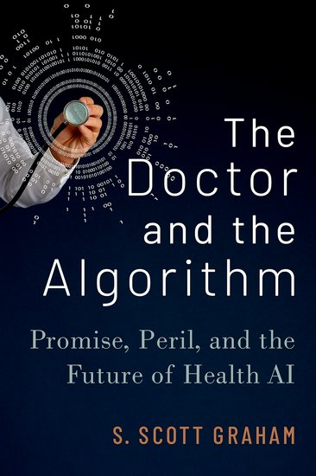
Abstract: We are routinely promoted to turn to “the science” in order to cut through the hype around healthcare innovation. This is especially true in the context of excessive hype around artificial intelligence (AI) in health and medicine. Rigorous research on the risks and benefits of health AI technologies should allow us to identify where PR and marketing communication leads to technology that overpromises and underdelivers. However, scientific reporting on health AI is not, itself, free from hype. Overly promotional language in biomedical journal articles can lead to premature deployment, diminished patient outcomes, and broader socio-relational harms. Accordingly, this presentation explores the nature of hype in biomedical writing on health AI, the hazards of hype-fueled premature AI adoption, and the possible avenues for intervention.
Bio: S. Scott Graham is an associate professor in the Department of Rhetoric & Writing at the University of Texas at Austin. He uses artificial intelligence (AI) and machine learning to study communication in bioscience and health policy, with special attention to bioethics, conflicts of interest, and health AI. Dr. Graham is the author The Doctor & The Algorithm, The Politics of Pain Medicine and numerous articles published in journals ranging from Rhetoric of Health & Medicine and AJOB-Empirical Bioethics to BMJ Open and the Annals of Internal Medicine. His scholarship has been covered in The New York Times, US News & World Report, Science, Health Day, and AI in Health.

